**Understand ‘+’, ‘>’ and ‘~’ symbols in CSS Selector**

 By Brij Mohan

It explains How to use different signs (+,> and ~) in CSS selector and their differences. Before starting, let us take a sample code to understand the signs.

[?](https://techbrij.com/css-selector-adjacent-child-sibling)

|  |
| --- |
| <div id="container">     <p>First</p>      <div>          <p>Child Paragraph</p>      </div>     <p>Second</p>     <p>Third</p>  </div> |

**Space:**

[?](https://techbrij.com/css-selector-adjacent-child-sibling)

|  |
| --- |
| div#container p{  font-weight:bold;  } |

It is the descendant selector. It will target all p tags within container div.

**> Sign:**

It will target elements which are **DIRECT**children of a particular element.

[?](https://techbrij.com/css-selector-adjacent-child-sibling)

|  |
| --- |
| div#container > p {    border: 1px solid black;  } |

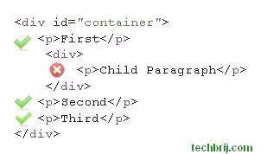

It will target all P element which are direct children of container div, not children of child div.

**+ Sign:**

It is Adjacent sibling combinator. It combines two sequences of simple selectors having the same parent and the second one must come **IMMEDIATELY**after the first.

[?](https://techbrij.com/css-selector-adjacent-child-sibling)

|  |
| --- |
| div + p {     color: green;  } |

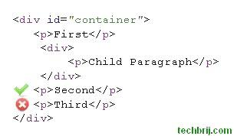

It will only select the first element that is immediately preceded by the former selector. In our example, it will target to Second ONLY because the owner P element comes just after Div tag.

**~ Sign:**

It is general sibling combinator and similar to Adjacent sibling combinator. the difference is that the second selector does **NOT**have to immediately follow the first one means It will select all elements that is preceded by the former selector.

[?](https://techbrij.com/css-selector-adjacent-child-sibling)

|  |
| --- |
| div ~ p{  background-color:blue;  } |

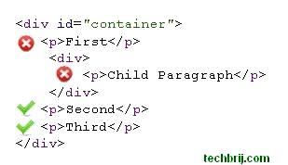

It will target both second and third.